**1. Title Page**

**Project Title:** Fitness Trainer Profile Page  
**Submitted By:**

* Name: RINEETH S E , PRAJWAL S HANGARGI , PRAJWAL V L
* Roll Number: 2462834 , 2462125 , 2462181
* Email: [prajwal.s@btech.christuniversity.in](mailto:prajwal.s@btech.christuniversity.in) , rineeth.s@btech.christuniversity.in , [prajwal.vl@btech.christuniversity.in](mailto:prajwal.vl@btech.christuniversity.in)   
  **Course:** UI/UX Design Fundamentals  
  **Instructor Name:** Ms.Nagaveena  
  **Institution:** Christ University  
  **Date of Submission:** 13/08/2025

**2. Abstract**

This project focuses on designing and developing a responsive **Fitness Trainer Profile Page** using HTML5 and CSS3. The page serves as a professional portfolio for a personal trainer, highlighting expertise, certifications, training programs, client testimonials, and contact information. The design emphasizes a modern, clean layout with clear sections and high-quality visuals to attract potential clients. Techniques such as Flexbox, CSS Grid, and media queries are implemented for a mobile-first approach, ensuring accessibility across devices. The final output is a visually appealing, structured page ready for integration with booking or scheduling systems.

**3. Objectives**

* Create an engaging and informative fitness trainer profile layout.
* Ensure seamless responsiveness across desktops, tablets, and smartphones.
* Apply branding through consistent colors, fonts, and imagery.
* Use semantic HTML for better SEO and accessibility.
* Organize trainer information into clear sections: About, Services, Testimonials, Contact.

**4. Scope of the Project**

* **Includes:** Front-end profile page design and styling.
* **Excludes:** Backend booking functionality or payment integration.
* Designed for modern browsers and responsive screen sizes.
* Uses only HTML and CSS without external libraries.

**5. Tools & Technologies Used**

| **Tool/Technology** | **Purpose** |
| --- | --- |
| HTML5 | Content structure and semantic layout |
| CSS3 | Styling, layout, and responsiveness |
| VS Code | Code editor |
|  |  |

**6. HTML Structure Overview**

* Semantic tags: <header>, <nav>, <main>, <section>, <footer>
* Sections include: Trainer Introduction, Specializations, Services Offered, Client Testimonials, Contact Information.
* Navigation menu linking to different sections of the page.

**7. CSS Styling Strategy**

* External stylesheet (style.css) for maintainability.
* Flexbox for aligning profile image and trainer details side-by-side.
* Grid layout for displaying services and testimonials.
* Media queries for mobile-first responsiveness.
* Consistent typography and color scheme to reflect fitness branding.

**8. Key Features**

| **Feature** | **Description** |
| --- | --- |
| Responsive Design | Adjusts to various screen sizes |
| Visual Branding | Uses theme colors and professional fonts |
| Highlighted Skills | Displays trainer's certifications and expertise |
| Testimonials | Client feedback section for credibility |

**9. Challenges Faced & Solutions**

| **Challenge** | **Solution** |
| --- | --- |
| Image scaling issues on small devices | Used object-fit and max-width properties |
| Maintaining layout symmetry | Implemented CSS Grid with equal column gaps |
| Text readability on images | Added semi-transparent overlay for text areas |

**10. Outcome**

* Developed a clean, professional fitness trainer profile page using HTML and CSS.
* Learned how to balance text, visuals, and white space for better UX.
* Enhanced understanding of brand-based UI design.

**11. Future Enhancements**

* Add a booking system with calendar integration.
* Include video testimonials or workout previews.
* Add dark/light mode toggle.
* Implement animations for section transitions.

**12. Sample Code**

<!-- Header / Intro Section -->

<header class="intro fade-in">

<div class="intro-text slide-in-left">

<h1>Rama</h1>

<p>Your Personal Fitness Trainer</p>

<a href="#services" class="btn pulse">Book Now</a>

</div>

<div class="intro-img slide-in-right">

<img src="rama.webp" alt="Fitness Trainer">

</div>

</header>

<!-- Services Section -->

<section id="services" class="services fade-in">

<h2>My Services</h2>

<div class="service-cards">

<div class="card hover-up">

<i class="fas fa-dumbbell"></i>

<h3>Strength Training</h3>

<p>Build muscle and improve endurance with personalized strength programs.</p>

</div>

<div class="card hover-up">

<i class="fas fa-running"></i>

<h3>Cardio Fitness</h3>

<p>Increase stamina and burn calories with fun and effective cardio sessions.</p>

</div>

<div class="card hover-up">

<i class="fas fa-apple-alt"></i>

<h3>Nutrition Coaching</h3>

<p>Get a customized diet plan to match your fitness goals.</p>

</div>

</div>

</section>

**13. Screenshots of Final Output**

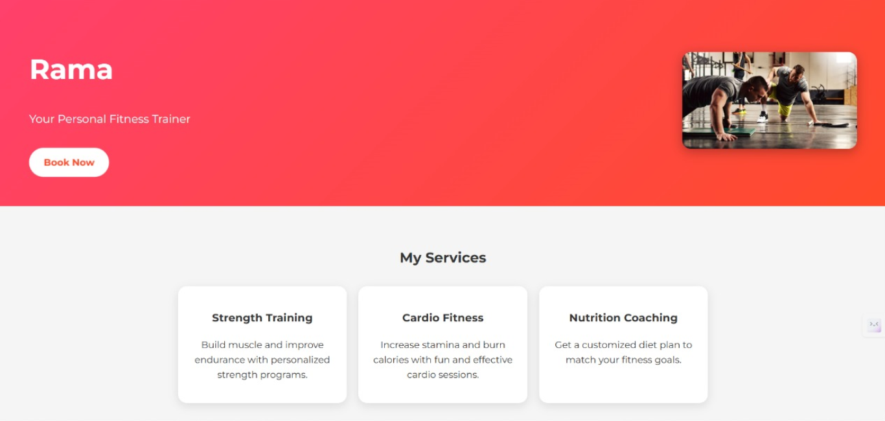

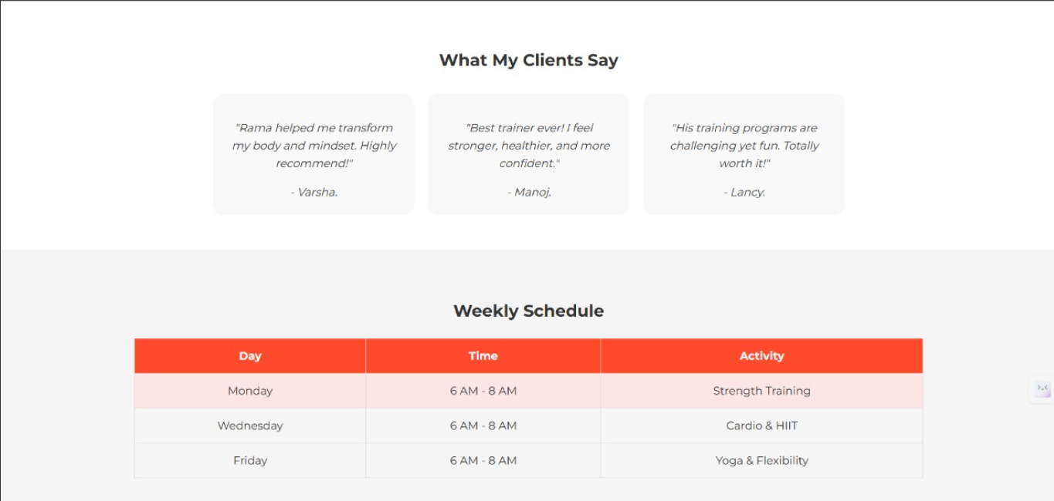

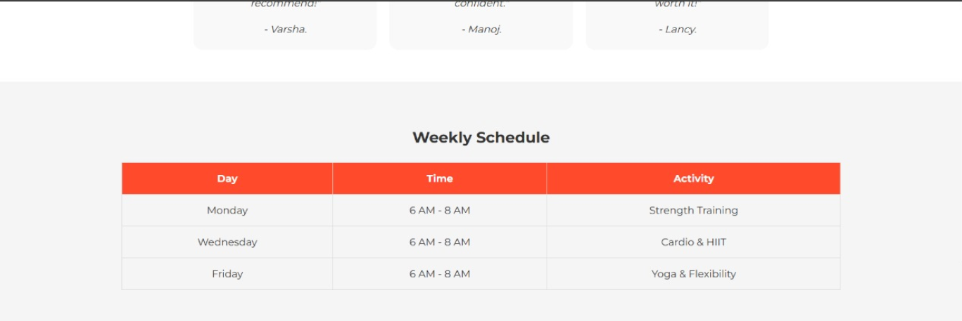

**14. Conclusion**

The Fitness Trainer Profile Page project strengthened my skills in responsive web design and branding implementation using HTML and CSS. It provided insights into structuring professional portfolio pages and creating user-centric layouts. This project can serve as a base for future enhancements, such as booking integration and interactive features.

**15. References**

* L&T EduTech LMS: <https://learn.lntedutech.com/Landing/MyCourse>